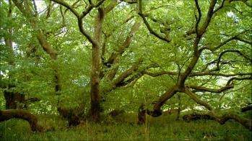
TREE STORIES
A multi-media, multi-sensory event,
following a sequence of trees
through the grounds of Corsham Court, Wiltshire.

By kind permission of Lord Methuen, James Methuen-Campbell

The event is conducted by Claire Todd, a multi-media artist and pre-Raphaelite wood-spirit; and
Henbedr y Coed, Old Peter of the Woods, a kind of tree-shaman of indeterminate age.
They are joined by Fred Harper, a professional percussionist.

Claire meets the gathering participants, and explains the nature of the event. She reads a passage of Einstein’s, about the need to synthesise science and imagination. Oh. Ah.

Claire calls: Henbedr, Henbedr!
Everyone joins in. Henbedr!
Henbedr: Pwy sy’n siarad? [he thinks in Welsh]
Emerges from behind a ginkgo tree
Henbedr: Ah, Claire, neis I weld ti! How lovely to see you. And you have brought friends! Welcome, welcome.
He continues

Ginkgo
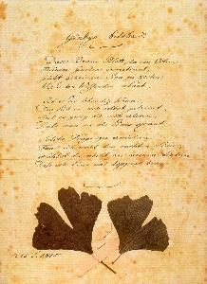
This tree? It is a ginkgo. These are the oldest living trees we have. Doesn’t it have a kind of prehistoric look? Fossil ginkgoes disappeared from the record and were thought to be extinct. Then a few living specimens turned up in the far east, and we have lovingly brought them back into our gardens and parks, as Goethe remarked:
Johann von Goethe's handwritten poem, with pressed ginkgo leaves.
Dieses Baums Blatt, der von Osten
Meinem Garten anvertraut
Claire: Henbedr, you’re talking German…
Henbedr: Oh yes, sorry.

The poem is about the two-lobed leaf representing our dual human natures – the focused and the fantastical, the literal and the literary, the scientific and the artistic, the rational and the rhapsodic [Shows the leaf, passes it round]
Its shape is somewhat like a cross-section of the human brain, which has two halves, one that is said to deal with facts, the other with imagination.
Our wanderings today will draw on both sides, to their mutual benefit.
They need each other.

[On the Court Lawn]

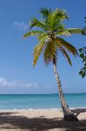
‘Being a tree’ has been tried in many kinds of plants, and given rise to tree ferns, palm trees, conifers, bamboos, and all the other trees we know. Their distinctive feature is simply: wood. Wood is a strong material that, if you’re a tree, you can add to every year, without having to look after it. The living parts of a tree are all near the surface. I think of wood as the bones of a tree, like our own bones. You could even say that, just as we like to divide the animal kingdom into two parts, the large vertebrates with bones, and the smaller invertebrates without, we could divide the plant kingdom in a similar way, the large trees with wood, and all the non-trees without wood. And we humans are upright too, like trees; we have spines, they have trunks. Being big among our kind is something we share with trees, although we shouldn’t get too big for our roots.
Two kinds of trees we shall not see on our journey: above, a palm tree; below, tree ferns.

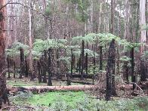
Trees play a long game. It takes time to build yourself up, year after year, so you have to think long and slow. Trees start a bit like people, very small, then after about five years the two are a similar height, then after twenty the same weight. It’s fun to grow a tree and a wee bairn together. Eventually people stop growing, but most trees carry on, bigger and bigger. They outgrow us and outlive us, and they have been on earth for much longer.

Eventually, like us, trees die, and their bodies become food and habitat for even more creatures, until everything that ever made them is returned to the cosmos. No waste, no contamination; and the cycles of life move on.

Magnolia
The most primitive of all the flowering trees, the basic pattern for all the species of flowering plants from buttercups to waterlilies. Another one from the time of the dinosaurs, still with us.

Before I praise the Magnolia for its most significant innovation, I should mention two other great inventions in the plant kingdom. One is the seed, which contains a tiny but complete plant in a firm but porous case, ready to emerge and seek its fortune, like a genie from a lamp. Look at these magnolia seed pods: you can see the seeds swelling just like human babies growing inside their mothers. The seeds are bright red, probably to attract birds who will help to spread them far and wide. Quite a lot of seeds are red.

Seeds grow from a single egg cell, but this cell does not develop until it is fertilised, just like in humans. In plants, fertilisation is done by pollen, invented long ago, but relying on the wind to blow it everywhere. Some plants still use this method – that’s why we get hay-fever – but wouldn’t it be neat to have a more precise way of bringing the pollen to the egg, from one flower to another?

The magnolias’ great innovation was to persuade flying insects to transfer pollen from one plant to another. So much more precise! Pollen is a rich source of protein, and is a good down-payment, but just to make sure, the Magnolias offered sugary drinks in the form of nectar. And to make sure of all this, they came up with a really stunning innovation. The flower!
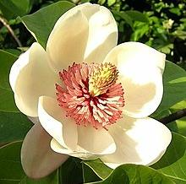
The magnolia flower is very basic, but it’s all there. It has four concentric layers. There are tough leaves that protect the buds. Here, you can see the flower buds, ready for next year. Then they open up to display the bright petals that attract the insects. Then there is a ring of male structures, stalks with pollen on the end, ready to rub against the visiting insects. Perhaps insects are like cats, they like to be stroked on their tummies, collecting pollen. Right in the centre is the female ovary, with unfertilised eggs ready to be fertilised by pollen from other flowers, brought by the insects. And right at the base, the nectaries, to produce sugar, making the insects get right in there. Brilliant.
The magnolia flower, in four concentric whorls
3
4
2
1
1

Most modern flowers are variations on this system, and you can see it working in any garden.
This collaboration between flowering plants and insects was so successful that it led to an explosion of biodiversity: 350,000 species of flowering plants and literally millions of pollinating insects. Now the land is 95% dominated by these two groups.

Yew
Look, quite a different kind of tree, but red berries again!

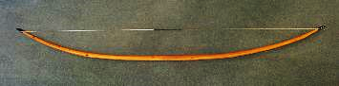
The yews were often grown in churchyards (like the ones you can see over the wall in St Bart’s churchyard). There, so the story goes, they were protected for making archery bows. Look at this yew stick. It is very hard to bend at all. But you have to bend it to string it. If you put your fist in the middle of the stick and extend your thumb, that tells you roughly where the string should be when the bow is bent and strung. That is the origin of the phrase, ‘a rule of thumb’.

Imagine the strength needed to draw a bow made from such wood. Imagine the force in an arrow loosed from such bow. Yes, it could pierce armour at short range. After church on Sunday, men were expected to practice archery on the ‘Butts’, like the area still called The Butts in Biddestone. Archery was both a sport and an essential military skill. If archers were captured by enemy forces they were not always killed, but had the first two right-hand fingers amputated to prevent them ever operating a longbow again. It became a feature of an English army’s challenge to an enemy to brandish these two fingers in order to demonstrate they were potentially deadly archers. I understand that this gesture is still used as one of defiance and contempt.

The wood has a delightful deep red colour that softens to brown in use. Wonderful for what was traditionally called ‘treen’, small practical domestic items made from wood. So much nicer than plastic. Look at this bowl, and this exquisite spatula, both in everyday use. [They are passed round]
The classic English longbow, using a yew stave

Holly
Oh look, red berries, yet again!
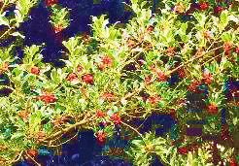
I am sure you know the Christmas song about the Holly and the Ivy. “Of all the trees that are in the wood, the Holly bears the crown”. That’s because it is evergreen, a symbol of eternal life. It’s quite different from anything else, and has its own family. The prickly leaves tend to be at the bottom, to deter browsers. At the top the leaves are plainer.

Harry Potter’s wand is made from holly and it serves him well against the forces of darkness. I have a holly wand here. If you know the spells, you can make things happen. [Points wand at Fred] “Tarantellagra!” [Fred starts to dance] “Finite incantationem!” [He stops]. I think I had better keep this wand in my pocket, in case any Harry Potter readers have remembered the spell for turning people into frogs.

Crab Apple
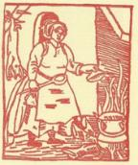
This is a small tree, one of the ancestors of the apples we eat. You can eat the crab apples too, but they are rather sour, perhaps best used for flavouring hot punch in the winter, as Shakespeare mentions in Love’s Labour’s Lost: “when roasted crabs hiss in the bowl”. It’s the song that ends every verse with “While greasy Joan doth keel the pot”. I like to think there was a real greasy Joan, and I’d love to have met her.
Perhaps Greasy Joan looked a bit like this. You can see the roasted crab apples hissing in the bowl

Like people, trees come in families, some common like Smiths and Johnsons, some rare like Uzzells and Ramsbottoms, some in the middle like Seymours and Thatchers. This tree is a member of the large Rose family. It doesn’t look like a rose, does it? But this family produces many, many fruits: pears, plums, cherries, quinces, strawberries, raspberries, blackberries, medlars, peaches, apricots, rowan berries, and even almond nuts.

The wood from these trees is smooth and often scented, and widely used for treen. Look at this handle, made to replace an old one that had rotted away. Feel it, feel how it fits into the hand. Pear wood. We could make many more domestic items this way.

Beech
Amazingly, beech is technically an immigrant, but made itself at home here. It’s in the same family as oak and sweet chestnut, and perhaps you can see why: pick up some of the nuts. The beech-nuts or beech-mast are beloved of pigs, and pigs were allowed to forage in the beechwoods to fatten them up for winter. In olden times a kindly Lord Methuen would have allowed us peasants to bring our pigs in here for their annual feasts.

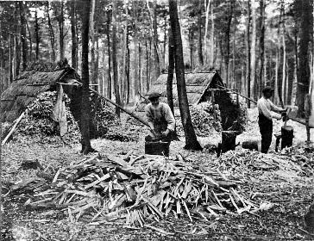
Sometimes, out of the blue, the trees produce a complete bumper crop, called a ‘mast year’; they all seem to know and they all do it together, but the decision must be made earlier in the year. I imagine the word going out: “c’mon everyone, we haven’t had one for a bit, let’s give them something to think about”. It’s a bit like a rave.

The beechwoods of southern England were once the home of bodgers and charcoal-makers, who lived in the woods the whole summer, making small items out of beechwood, which is very hard and durable. They used pole-lathes to make chair-legs, like this chair you see here. Their biggest order ever was for tent-pegs in the first world war, and here is a sample.
Bodgers in the beechwoods. The person in the centre is making chair-legs with a pole-lathe, a huge pile of finished items in front of him. They were very fast. In the background you can see the thatched bothies where they slept.

As well as more treen, like this screw nutcracker, beech is used for musical instruments, especially percussion. Here is a simple shaker [Fred demonstrates] and here are woodblocks [another demo]. Listen to that sound. Doesn’t it say ‘something’s happening in the wood, far away’?

Hazel
All our trees were driven out by the last ice age, which started about 100,000 years ago. They retreated to Southern Europe, like some humans still do. Here in Wiltshire, there was no actual ice sheet, but it was like tundra. Perhaps we had lemmings, reindeer, fur-clad hunters, but no chance for trees.

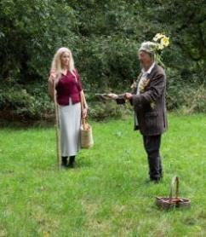
Of course, trees can’t walk. They recolonise an area by sending seeds ahead, bit like grandmother’s footsteps. You look away, and when you look back there are seedlings growing a mile away from their parents. It takes a while, but remember trees are playing a long game, and in a thousand years they can cover a thousand miles. The sea level was low. There was no North Sea, no English Channel. It was easy for things to move and get their seeds spread, but it just needed to warm up a bit, and eventually it did. It started with willow and birch trees, then pines, hazel, quite small trees, then oaks and elms, alders and limes. They all moved north, spreading their seeds before them, until one day, the sea level got so high it started to form the channel. Then the North Sea appeared, and the British Isles became, well, the British Isles. All the trees that were here by then, about 8000 years ago, are considered Native. The rest are (ahem) immigrants, even though they have been here for hundreds, even thousands, of years, and made themselves completely at home, like the beeches. Just as with people, in some sense we are all immigrants, and we all have our parts to play.
Henbedr-y-Coed demonstrates the use of the forked hazel dowsing rod. Claire seems unconvinced.

Hazels were one of the first trees to recolonise Britain after the ice age. They have lovely nuts, but the squirrels usually get them first. Hazel used to be used for coppicing, cutting the stems almost to the ground and letting the new stalks grow up together: they make lovely poles for beans and hurdles, and for wattling, which we shall see later.

Hazel was also favoured for making dowsing rods for finding water underground, like this [demonstrates technique; others have a go too]

Plane
Here is another immigrant, but now part of our scenery. Big in London and Bath. The Court grounds here contain the one with the largest spread anywhere.
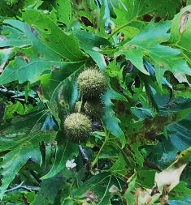
A tree is not just what you see. There is another invisible ‘tree’ of roots underneath, like a reflection in a lake. Imagine the size of the underground tree here. We are standing on it. The roots are entangled with fine threads belonging to fungi. The tree wants phosphorus, and the fungi are happy to collect it from the soil and share the surplus, in exchange for sugar, produced in the tree’s leaves and sent down to the roots, in part for trade. It’s an ancient and happy arrangement.

Planes have strange ball-like fruits that are good for throwing at your friends, perhaps even your enemies. Claire, I believe you can even juggle with them… [she demonstrates]

Maple
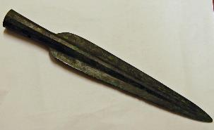
Maples were given the name Acer from Latin. I think it is connected with various words meaning ‘sharp’ or pointed (like acid and acute) because they were used to make spear shafts. A Roman soldier would make holes in the ground with a spear-shaft, and drop a maple or sycamore seed into each hole. They would sprout and grow very straight, making ideal spear-shafts, like this one. [Demonstration of making a hole and burying a seed; kids do it]. Then all you need to do is fit a spear-head onto the shaft.
A Roman spear point, showing the socket that fitted onto a shaft.
This is probably why the sycamores are here. They are not strictly native, but ever since the Romans brought them, perhaps along with rabbits, they have made themselves at home.

Maple is used for percussion instruments like claves, and also for simple whistles, like this, that lend themselves to ancient modal melodies [shows whistle, plays ‘As I walked out one May morning’]

Elm
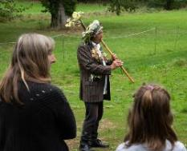
This empty space marks the missing elms, missing because of the terrible disease that struck us in the 1970s. They were an important part of the British countryside, and sorely missed. Elm wood does not split easily, so was used for things like chair seats and the hubs of cartwheels. Good for chopping blocks too, like this one, I think of as a ‘pariah block’, used to chop things like garlic and chillies. You can see a split has started, but does not get any larger. Elm was used in old buildings too for seats and stairs, like in the old chapel in Monk’s Lane. Look at this chair seat, all one piece, made with an adze in the woods, along with the beech legs. It even has a number pencilled on it: the woodsmen needed to tally their products so they got paid properly.
Henbedr plays a medieval tune on the cornamuse, a forgotten double-reed instrument that sounds like a duck. This one is made from elm.
Elm was even used for making musical instruments. Here is an instrument with an ancient history, that plays old tunes.
[The cornamuse: plays The Horses’ Bransle]

Box
Box is evergreen, and common in some woods. It grows slowly, and so the wood is very dense and hard. But it’s a small tree: you can’t make planks out of it. It was often used for tool-handles, woodwind instruments, and most notably for rulers, because it would take very fine markings. Our grandfathers all had these – marked in inches of course.
[Shows classic folding ruler] 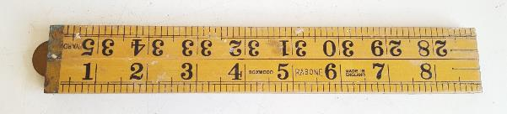

Sometimes box cannot be found, but surprisingly, elder wood can be used instead. Look at this small elder log, how hard is the wood, and how tight the grain. Elder produces fragrant flowers and vitamin-rich berries, and you will have a chance to sample them later in the form of drinks.
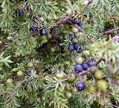
Juniper
has become quite rare in Britain, but is important because its berries are used to flavour gin. In continental Europe they drink schnapps and vodka; Britain prefers its gin. Just compare the smells of these two bottles, and you’ll know what juniper smells like. [Small glass jars are passed around].

Cypress
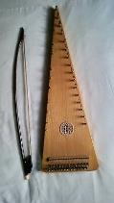
There is a whole family of trees like this, with tight, fleshy leaves, including the juniper. They have a strong, aromatic smell. Rub them in your hands. The larger ones produce wood that is prized for musical instruments. Cypresses are evergreen and often associated with heavy shade and sombre moods. It is true, they easily produce mournful sounds [plays The Leaves Be Green, an Elizabethan tune, on the bowed psaltery].
Another forgotten instrument, the bowed psaltery, often made of cypress.

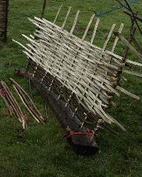
[Through the gates into the field. A refreshment break]
Edible gifts from trees

Apple rings/’biscuits’ from cooking apples
Hazel nuts in their shells – need cracking with the beech crackers

Apple juice
Elderflower cordial
Elderberry cordial
Damson vodka

Do-it-yourself hurdle making or wattling, using hazel wands.
The wattling process, weaving wands of hazel or riven oak between uprights. This was sometimes sealed with ‘daub’, a mixture of clay and cow-dung.

A variety of percussion instruments made from wood, nuts, shells. Shakers, claves, rattles

Sweet Chestnut
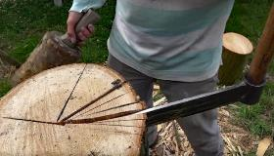
This is in the same family as oak and beech. The nuts – chestnuts – are very nice, but don’t grow big in Britain. But we still grow the wood for its resistance to decay, like oak. Fences used to be made from ‘chestnut palings’, and these were made by ‘riving’ or splitting the wood into long staves using a mallet and a large, handled blade called a froe. Splitting is better than sawing because it follows the grain of the fibres and does not expose end grain to organisms that could rot them.
[Rive a billet using froe, perhaps make a sample paling; show a ‘shake’]
Look at this blue stain. That is a reaction of the tannins in the wood with the steel of the froe, and it’s something that oaks and chestnuts share. The tannins act to slow down decay.
A chestnut log being split using a froe and mallet. Notice the wood is split 'on the quarter', that is, radially from the centre. This minimises distortion as the wood dries.

Oak
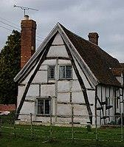
The grandest and most famous of our native trees. The wood is very tough and resistant to decay, so it was used in old houses as a basic frame, like you see in Lacock. A favourite trick was to split a curving branch in two and then connect them in a mirror-image to make a frame for the walls and roof of a house. These are called crucks and you can still see them at Lacock.

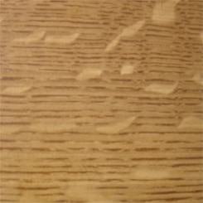
Oak was also used for treen: look at this little bowl, using the twisty burrs that oak sometimes produces. And…more shakers [Fred demonstrates]

Oak wood has very strong radial elements, and if you cut along them they refract light in an attractive way, hence the figuring you get in some old oak pieces. You can see it here.
A cruck frame, using the two mirror halves of a curved, then riven oak beam. The rest of the wall is oak-framed with wattle-and-daub infill.

The fruit is of course the acorn, like beechmast fed to pigs (oak and beech are in the same family). But there is a lost tradition of eating acorn kernels directly, perhaps due for a revival. I consider eating acorns a kind of sacrament that connects you to the brotherhood of oaks. Here are some acorns that have been boiled and dried. They can be re-soaked and eaten, just like chestnuts.

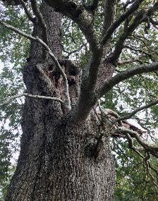
From here you can see a very old oak that was probably here at the time of the great forest that stretched all the way from Melksham to Chippenham, even before the time of Henry VIII. Imagine that! There is also a blasted oak damaged by lightning, can you see it? That always reminds me of Robert of Normandy, who was a prisoner in Cardiff Castle in the twelfth century. From his cell he could see a blasted oak like this on the skyline. He identified with it and wrote poems about it, in old Welsh
Dar a dyfwys ym meillion
A chan a’i briw bi ni gronn

Blasted oak among the weeds and clovers, may the song of your wounds grow no louder.
Heartbreaking!

Oaks are home to hundreds of other species that live on them, in them and off them. An oak in leaf is the greatest of the tree galleons, loaded with treasures, sailing on through the summer days with their enormous cargoes. Take a few minutes to look at the twigs of this tree using hand-lenses. You will see all manner of lichens, mosses and other creatures all living on the oak. This is the entry to the other worlds of the smaller and smaller and stranger and stranger.

Ash
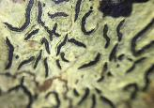
While you have your hand lenses, look at the markings on this stick. It is not oak, but ash, and I use it as a staff to steady my old limbs. If you look closely with the lenses, you can see mysterious writing, which only I can understand.

Ashes are tall, elegant trees that come late into leaf and lose their leaves early, as if they enjoy their winter sleep. The wood was prized as being able to withstand shocks, so was used for tool handles, and many parts of farmyard carts. Unfortunately, the wood does not withstand the wet, so carts needed to be kept under cover. This had an effect on farm buildings: from about the 17th century farmers started to build special sheds for the carts, and then used an upper storey to store grain safe from rats and mice. The combined cart-shed-granaries are very common on farms here in the Cotswold area.
Mystic runes on Henbedr's ash staff

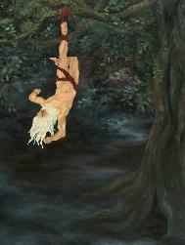
The ash is revered in Norse mythology as Yggdrasil, the sacred world-tree whose roots and branches embrace the whole cosmos. We still names days of the week after Norse gods: Tuesday, Wednesday, Thursday, Friday. It is said that Odin himself, king of the gods, sometimes called Wotan, after whom Wednesday is named – did you ever wonder why it was spelled that way? – hung upside down for nine days from Yggdrasil, and sacrificed one of his eyes, in order to learn how to read the mysterious runes, like the ones on my stick!
Odin, king of the Norse gods, hangs from Yggdrasil, the World Tree. The resemblance to the Taro image of ‘The Hanged Man’ is not accidental.

Ash provides lots of treen of course: look at this neat little wedge. Lovely blond-coloured wood, with a tasteful grey grain. Ash can also be used for percussion instruments, and is particularly good for rasps and rattles
[Fred demonstrates the guiro and the kokoriko]

Ashes are now suffering from a disease, like the elms did: ash-die-back, so many will be felled. We might see a surge of ash wood, but sadly, fewer ashes in the landscape.

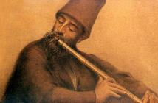
Bamboo
Bamboo is what happens when grasses decide to become trees. In some countries bamboo is as high as tall trees. Here it is smaller, but it is always hollow [cut and demonstrate]. This makes bamboo especially good for making wind instruments, but they have each have special qualities. For example, the transverse flute sounds round and silvery [play Il a passé par ici]. Pan pipes are piercing, like a train whistle [play Baa Baa Black Sheep]. The strangest of all are the completely hollow pipes of the middle east, played with a sideways technique that produces a howling or shrieking sound [demonstrate]. This was the basis of an allegorical poem by the mystical poet Jalal ud-din Rumi, Listen to the Reed. It sounds better in the original Persian
A Turkish musician playing the ney. His hat shows him to be a member of the Mevlevi sect, founded by Rumi himself, famous for their elegant whirling dances.

Beshno az nāy, chun hekāyat mikonad
Az jodāyi ha shekāyat mi-konad.

Kiri, Pauwlonia or the Foxglove Tree
An oriental tree, but it seems to like it here. In Japan it is called kiri, and is famous for its light but strong wood, used for drumsticks, like these (pass around). The wood expands when hot, so is used to make chests for valuable kimonos. In old Japan, people lived in light wooden houses that often burned down, but chests made from the wood of this tree sealed them in and prevented fire and smoke damage.
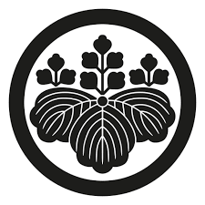
You can see the flower and the leaves on the tree, and on this medallion, a formalised symbol called go-shichi-no-kiri. This one is from a temple in Kyoto. No, since you ask, it did not ‘fall off the back of a temple’. It was given to me by the abbot.

The kiri crops up a lot in poetry. There is famous haiku
Kiri hitoha
Ochite tenn ka no
Aki o shiru
Go-shichi-no kiri crest, instantly recognisable by any Japanese.

I like this haiku because it has quite a different feeling for us than it does in Japan. It means simply this: ‘one kiri leaf falls, and we know that autumn is coming’. For us, this has a melancholy, elegiac quality, but in Japan it is quite the opposite, because it means the end of the oppressive heat of summer, and the start of the beautiful, balmy autumn season.

The drumsticks here are used in Taiko drumming.
[Fred introduces the traditional prelude to a Taiko session: ichi, ni, san, shi (one two three four in Japanese) and suggests a mnemonic. After everybody has said it, he gives a short demonstration. Wow.]

[Everybody has some kind of percussion instrument. Fred shows how to play off the beat. Henbedr plays an Irish polka, The Rakes of Mallow on a high whistle, Fred plays the on-beats and everyone joins in on the off-beat, with three repeated beats at the end. This is the end of the peregrination]

TEA AND CAKES
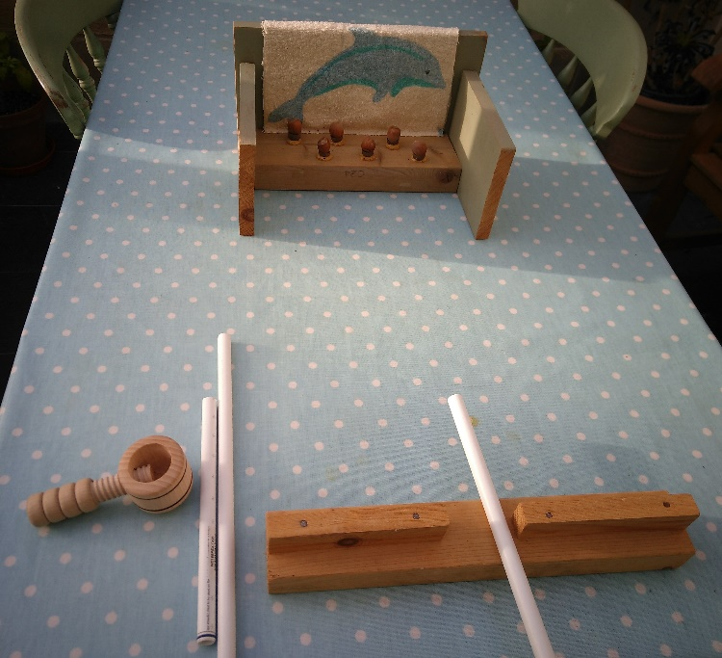
In St Bartholomew’s church, hard by.

Children used the acorn shy to knock acorns out of their cups. It is like a coconut shy, but very small. Instead of the traditional wooden balls thrown by hand, they use peashooters and dried peas.

The 'acorn shy' with acorns replaced by hazel nuts. The nuts are the prize, cracked in the nutcracker on left. You fire peas at the nuts through the pea-shooter tubes, over a wooden 'sight'.

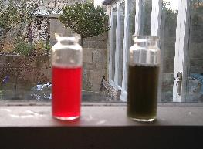
If they succeed in knocking nuts out of the cups, kids get to crack the nuts, and a chance to use the holly wand. With elderberry juice and a magic potion, the incantation “Colorem Mutatis!” will change its reddish colour to green.

Children were heard muttering the spell as they went home with their parents.
Vials of elderberry juice before and after the incantation "Colorem mutatis"

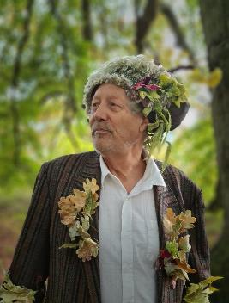
Henbedr-y-Coed, in regalia created by Claire Todd

POSTSCRIPT: YET ANOTHER STORY FOLLOWING ON FROM THE TREES EVENT

A new community garden is being created in the grounds of The Pound Arts Centre, in Corsham. Its most striking feature is rows of fruit trees, recently planted but due to be trained in various ways. A local artist, Chloe Alexander, who had joined the Tree Event in 2021, noticed that one of the fruit trees was a damson called the ‘Shropshire Prune’.

Encountering Henbedr y Coed in town one day, she remarked that she had once lived in Shropshire and local legend had it that the damsons were used to dye the uniforms of the local soldiers off to fight in the first world war. This struck Henbedr as unlikely, and since it happened to be April 1st, he regarded it as an April Fool spoof.

Later, however, he idly googled the matter and discovered that yes, it was really true! Damsons were formerly grown in Shropshire as a dye crop, not to eat. The puzzle was, how can that brilliant deep crimson become army khaki?

The answer lay, of course in ‘Colorem Mutatis’. If elderberry juice could be turned from red to green with a simple Magic Potion, why not Damson juice? Scientifically speaking, these anthocyanin pigments act as ‘indicators’ of acidity, rather like litmus paper. They are red when acid, but other colours when alkaline. It just remained to experiment a little, and glory be, adding alkali did indeed turn the bright pink into a greeny-brown.

The question then, was, what would the Shropshire dyers use to convert their crimson dye to khaki? In those days the cheapest industrial-scale alkali was, ahem, stale urine. Urine contains urea which, after standing, gradually turns into ammonia, a powerful alkali. It would have been readily available locally, and this was almost certainly what they used. By carrying out a few simple experiments, Henbedr confirmed that it worked.

He is a strange old man.

