THE MEADOW
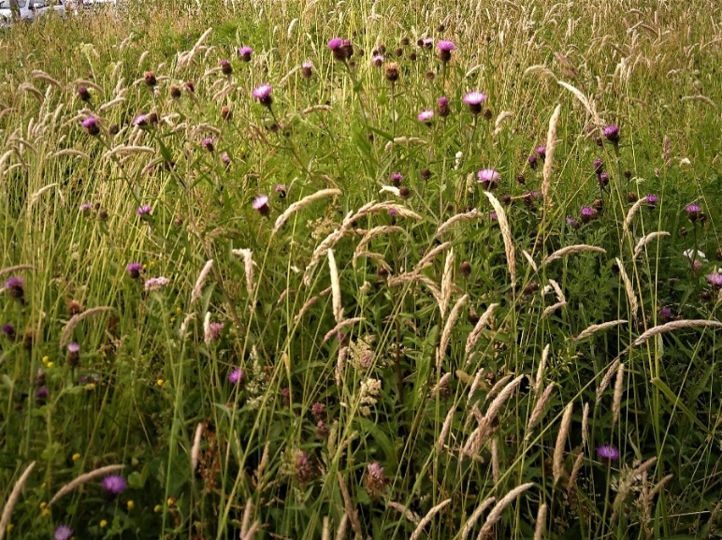

What’s the opposite of a poisoned chalice? Is it pennies from heaven?
I’m spending them now.

I have the task of managing a wildflower meadow, which has somehow dropped into my lap. I’ve always wanted an old-fashioned meadow, full of flowers and insects and grasses in bloom. Normally such meadows are cut for hay, or kept grazed, but this one needs managing by cutting from time to time and I’m doing it in the old way – with a scythe!

Scything is good exercise and incredibly satisfying. It attracts an audience. This particular meadow is not in the countryside but attached to the community centre in my town, which includes the Library, swimming pool, nursery and children’s playground: you know the kind of thing. When scything I always have a little retinue of kids asking me questions and wanting a go. No!

Managing the meadow gives me a chance to watch the annual cycle and notice the emergence of the different species. I see the differences across the patch, who turns up when. There are about forty sorts of native wildflowers, each with its resonant name. It’s poetry, you can chant it
Lady’s Bedstraw, Ragged Robin,
Birdsfoot Trefoil, Ox-eye Daisy,
Sorrel, Mugwort, Yarrow, Teasel,
Dock!
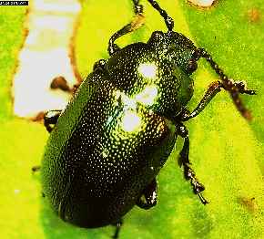
Yes, there are ‘weeds’, like docks, but they all play a part. The dock is host to an amazing beetle, a greeny-golden jewel in the summer sun, with scary-monster babies. There are lots of insects in the meadow, although my friend Jack, a butterfly expert, has been a bit disappointed.

We’ll see how things unfold….

Some observations on October 28, 2019

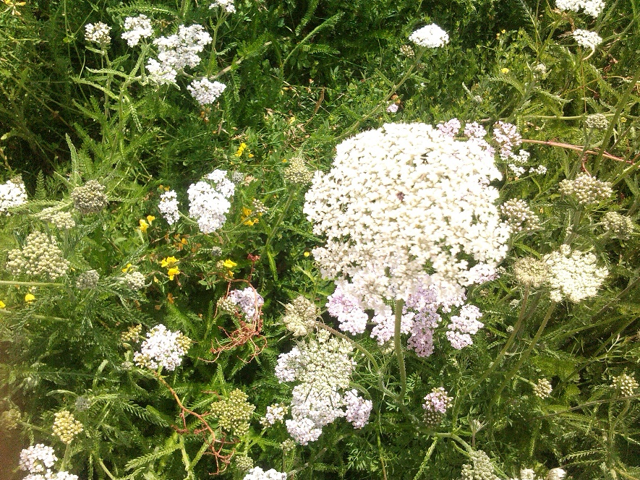

I am infamously geeky. Once upon a time, long ago, I formulated a slogan for progressive gardeners:
A RESULT IS WORTH 1000 CABBAGES

The meaning should be obvious enough: that there are plenty of cabbages in the world and a few more are neither here nor there. What we lack are observations about how to grow cabbages better that could help thousands of others, indefinitely into the future. So, gardeners should amplify their efforts by experimenting, recording and disseminating their results (and of course you can still eat the results).

In this spirit I have been managing a wildflower meadow, established in several sections at the Springfield Campus in Corsham, Wiltshire in 2016. I ‘took it over’ in 2018. I manage entirely by selective mowing. In 2018 I used motorised equipment, and in 2019 hand-tools only, a scythe and a push-mower, although I expect a motor-mower might be needed for a final clean-up at season’s end.

One purpose of the meadow is to provide a diverse area of plant biodiversity (at least 30 species) and the associated habitat for many other organisms. Probably more important is that the flowers are visible and able to be enjoyed by the passing public, with perhaps a bit of public education along the way. To this end I have produced information panels, and they are mounted around the site.

What I do is to allow the spring growth to emerge, then mow a margin of around 1 metre to create a general impression that ‘it’s meant to be like this’. I also carve curving ‘rides’ through the meadow to allow access and greater visibility. In the autumn I gradually increase the mown area, leaving a few stands like reverse crop-circles. Then it’s all mowed for the winter.

AN OBSERVATION

The theory of such meadows says that mowing will encourage grass, simply because grasses grow from below while ‘forbs’ (non-grasses) grow from the tips. Therefore, my mowed edges and rides would be grassy, and the areas left to grow would be richer in wildflowers.

This was the case earlier in the year, but as the season progressed, it was quite the opposite: wild flowers were more abundant and more visible in the marginal areas and rides.

Why might this be? I am not sure yet, but probably what is happening is this: scything is hard work and I do it less than I used to mow. Further, I cannot scalp the sward quite so low and efficiently as the motor mower. Meanwhile the wild grasses in the meadow itself are growing very quickly and obscuring the wildflowers. The grasses themselves can be very beautiful in their prime, but soon senesce and form large brown stands swamping the wildflowers. In 2019 these were even upstaging the late-flowing wild carrot and yarrow, shown in the picture above.

Left to themselves, most forbs have a natural flowering period, and for the British flora the average peaks in May and June. But many forbs can be induced to keep flowering if they are ‘dead-headed’, just like many garden flowers. This is one of the effects of infrequent and not-very-efficient mowing, and could explain the vividness of flowers in the mown areas later in the season.

IMPLICATIONS

The suggestion is that a different mowing-regime could be adopted, but I shall have to think very carefully about what this could be, given the complex geometry and viewing angles of the various sections of meadow.

I should probably take greater care to monitor and photograph the various areas week by week, or at least month by month, and observe the results of different mowing regimes.

It would be as well to leave at least some areas completely unmown, but others would have mowing regimes timed and recorded. The main thing is to keep most of the area mown lightly, rather than simply letting it rip.

AN UPDATED REPORT ON THE SPRINGFIELD MEADOW JUNE 2023

I found it difficult to follow the recommendations of 2019. Too much hard work! However…

It is not quite clear why, but 2023 has been the best year so far regarding the balance of wildflowers and grasses, at least at the ‘Fire Station End’ in June.

Here is a photo, taken on June 29th, 2023:
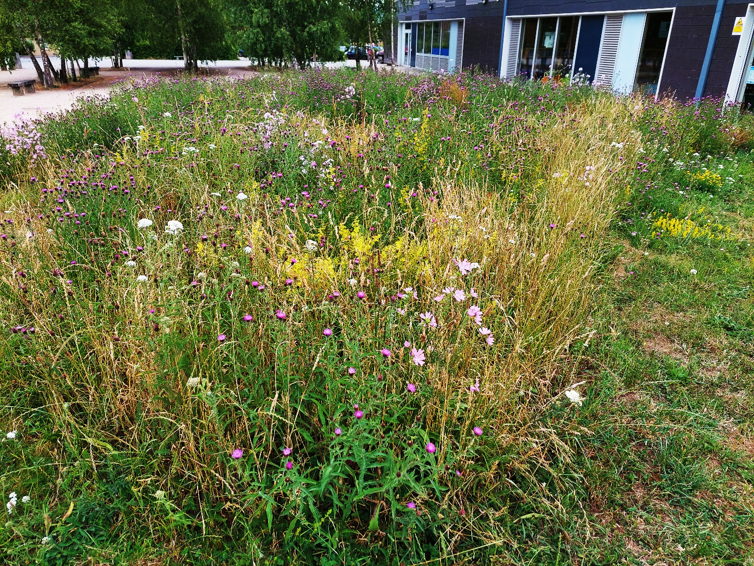

Undoubtedly, to the general public, this is just a mess and ‘weeds’. They would probably prefer it to be mown grass. But the original planners were aware of a need for ecologically-positive planting around the Campus site, and I – representing the local environment group, Corsham Climate Action – have taken on the task of managing the area, mostly by scything and mechanical mowing during the last five years. The original contractors did not deliberately impoverish the soil (probably they were unaware of the need) and the result has been that grass has dominated quite strongly. This would be fine if the main purpose were making hay, but if the purpose is to maximise diversity and create displays of wild flowers, the results so far have been poor. The 2023 ‘results’ suggest we might be turning a corner.

The view above is eastwards, with the Campus buidlings in the background. The general balance of grass and flowers can be appreciated. Possible the removal of plant material over the years has depleted the soil fertility enough to shift the advantages away from grasses. To the right is a mowed ‘ride’ created as a path through the meadow, but also to improve access and appreciation of the flowers.

At this time of year, the commonest flowers are:
Lady’s Bedstraw (Galium verum)
Black knapweed (Centaurea nigra)
Musk Mallow (Malva moschata)
Wild Carrot (Daucus carota)
Perforate St John’s Wort (Hypericum perforatum)
White Campion (Silene latifolia)
Common Sorrel (Rumex acetosa)
Bird’s Foot Trefoil (Lotus corniculatus)
Lesser Trefoil (Trifolium dubium)
Red Campion (Silene dioica)
Red clover (Trifolium pratense)
White clover (Trifolium repens)

Here is a closer look, taken on the same day. I have a high-resolution copy that can be zoomed into and examined at leisure. Among the common grasses such as cocksfoot and Yorkshire fog are large stands of lady’s bedstraw (the fluffy yellow flowers) and black knapweed (the pink-purple thistle-headed flowers). To the trained eye, this is attractive, but not to the general public. Often, when I am mowing, people stop and say “Can’t you weed those grasses out?”

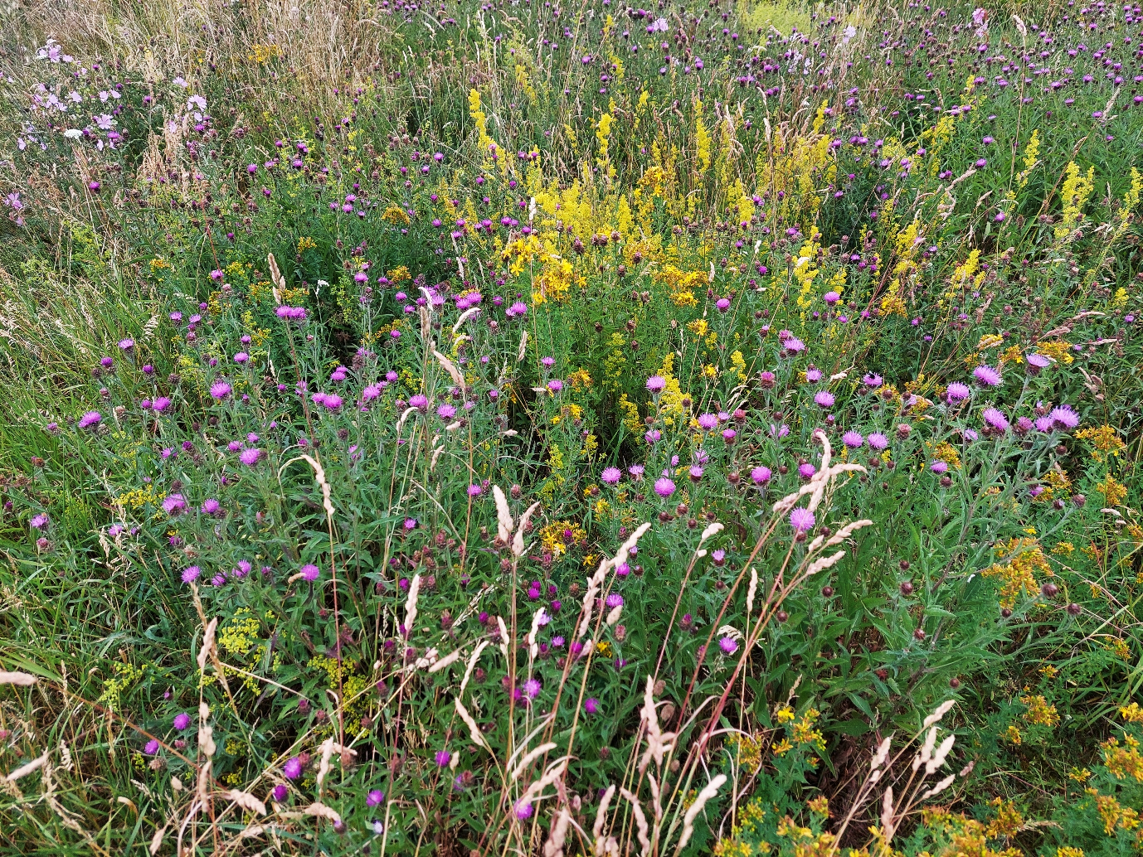

Another problem of public perception has been the publicity attached to the ‘cornfield annuals’ that comonly occurred in cornfields, such as cornflower (Centaurea cyanus), corn marigold (Chrysanthemum segetum), corncockle (Agrostemma githago), common poppy (Papaver rhoeas) oxeye daisy (Leucanthemum vulgare) and corn chamomile (Anthemis arvensis). These have spectacular, vibrant colours; can be sown independently of any cereal crop; and are highly attractive. I have created just such a display in the Corsham Community Garden, illustrated below.

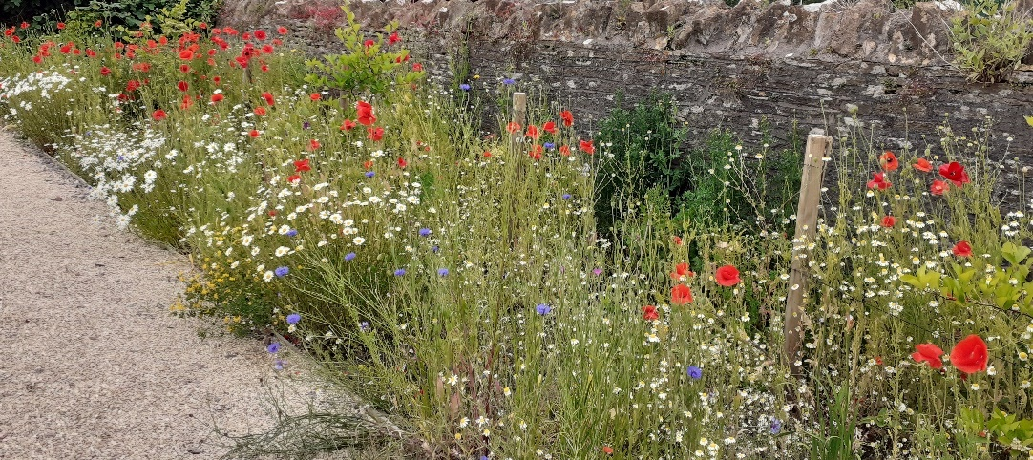

Such plantings have often been called ‘meadows’ and anything labelled ‘meadow’ is expected to look like this, which of course the campus ‘meadow’ does not.

Let me explain the difference. Cornfields were usually ploughed before sowing, and this triggered germination of the standard cornfield annual ‘weeds’ listed above. They grew up with the corn and made a pretty sight, set seed and disappeared. They are annuals, depending on seeds for future propagation. If we use these to create flower borders they usually last only a year. If they are allowed to set seed they might generate another crop, perhaps at another time, in the following year. Then they collapse and look scruffy, needing considerable attention to restore appearances. Effects in subsequent years are erratic.

The true meadow is quite different. It is designed not to produce corn for people, but hay for animals, mostly grass. It is never ploughed, but cut, usually twice a year, traditionally with scythes, left to dry, then gathered and stored as hayricks or under cover. The non-grass plants grow up at the same time, but are perennials, sparser and much less showy than the cornfield annuals. Usually they dry with the grasses and become part of the hay crop. Animals seem to like them.

Now we can go back to the beginning. Rich soils favour grass over non-grass plants (often called forbs) but as the years go by nutrients are removed in the crop and rarely replaced. Gradually the nutrient content of the soil declines, and this favours the forbs. Many long-established hay meadows have reached this stage and have become admired, not for their yields of hay, but for the diversity of the forbs, which being perennials, are reliable as clockwork. It is just this process that we might be witnessing in parts of the Springfield Campus meadow.

