THE GIDDENS PARADOX
Peter Harper
September 2013

This is my ha’porth for the seminar process.

The label ‘Giddens Paradox’ is taken from Anthony Giddens’ 2008 book The Politics of Climate Change. He remarks how odd it is that, faced with what in any reasonable perspective must the greatest challenge ever faced by humanity, the response is so muted.

That’s it really, but part of the paradox is that just stating it plainly is not enough. It has to be unpacked, argued out, and even that of course is not usually enough to get it seriously onto the table, even in fora like this. So let me enlarge a bit.

The label itself is of course slightly tongue-in-cheek. “We” in the sustainability racket have been banging on about it for decades – I mean, not just the problem itself but the puzzling fact that few will take it as seriously as it warrants. Even to get it on the agenda apparently requires a very distinguished social scientist to swan into the field, notice the oddity, imagine that nobody else has done so, and name it after himself! So there it is.

I don’t suppose, in this context, I need to discuss the basic science behind the climate problem, or the very large economic and other forces that are driving it. Take these as given. It is the structure of the problem that concerns me, because potentially at least it is both
  - very serious and
  - irreversible.

These make a difference.

By ‘very serious’ I mean that the even the best-case scenarios are unpleasant, and they are unconvincing. The worst-case scenarios are completely apocalyptic, although perhaps they too need a pinch of salt. Just taking fairly routine projections of the likely physical changes and working out what effects they must have on real human populations in various parts of the planet, is enough to reveal a world that contradicts everything ‘we’ (in enlightened groups like this one) have spent our lives working for.

Personally I feel humanity has made rather rapid moral progress since the end of the second world war. That war was admittedly a low point in the trajectory from Habeas Corpus, the Congress of Vienna, the ending of slavery, democracy and universal suffrage, the Nuremburg principles, the welfare state, the UN and its agencies, the Universal Declaration of Human Rights, international aid, the rights of gays and other minorities…and so on. We have become much more civilised, civil. Overall, trust, ‘social capital’ has increased, or so it seems from a privileged western perspective.

You could generalise all this in terms of a shift from zero-sum to non-zero-sum thinking: optimising resources on a collective rather than private basis. On a world scale we have not been doing this very long, but I think in principle we’ve got the trick of it. That is, we know how to do it if we really want to.

For bien pensant opinion this of course is nowhere near enough. There is so much more to do. Yet, given the trajectory of ethical progress I have sketched, it is entirely credible that in (say) a century hence we could be enjoying a kind of universal “Sweden” where the ancient problems of hunger and preventable illness are forgotten, wars are unnecessary, all rights are respected, wealth is well-distributed, borders are secure but porous, and a benign tolerance reigns.

Of course the human condition will not be abolished. There will still be earthquakes and divorces and status rivalries and babies’ bottoms to clean. But we can dimly sense the culmination of what we might call ‘the Enlightenment Project’ in which we are all engaged. It is not in principle impossible.

What I am saying now, is that none of this will happen, none of it can happen, if we do not somehow ‘solve’ the climate problem. ‘Solving climate’ is a necessary condition for the completion, or even further progress, of the Enlightenment Project. In passing, I hope this is not taken as a bombastic attempt to upstage all the other issues to which we have each attended, but if my argument is correct the ‘climate problem’ must play a part in most other concerns.

Let me move on to the ‘irreversibility’ aspect. The classic reversible environmental problem cycle works like this. A problem starts to build up – say, acid rain. Ecologists notice and make models. Years pass and more data confirm the models: they point to an incipient unsustainable situation: if continued this will end in tears. The mainstream environment movement gets involved, points out where things are headed, tries to persuade everyone to Do Something. Industry drags its feet, buys scholars to justify the status quo, funds contrarian organisations; the public does not care; government keeps quiet.

But eventually the damage gets so bad nobody can really deny it. Economists calculate that yes, in terms of ‘willingness to pay’ it would be worth dealing with. Government realises it could be quite popular. New laws are passed, an inspectorate set up, new technologies installed, pollution levels decline, impacts gradually recede. Environmentalists congratulate themselves, and so do economists, who proudly claim it was all market forces what done it.

This cycle applies (and has) to most of the classic environmental problems that first emerged in the post Silent Spring era of the 60s: eutrophication, lead in petrol, urban air quality, acid rain, noise, many food additives, toxic components of paints and other products, exploitation of peat bogs, conservation of endangered species, the ozone hole etc. etc.

One of the big difficulties in overcoming the Giddens Paradox is a widespread assumption that Climate Change will fit this pattern. It is viewed as follows. Greenhouse gases are allowed to accumulate in the atmosphere, and the climate responds in a linear sort of way, proportional to the forcing. Environmentalists bleat in their habitual way, but economists and politicians are confident that the intrinsic properties of the ‘cycle’ will bring about a solution at minimum financial and political cost. They assume that sooner or later we will get to the point where it is worth acting, and we will do the normal things; emissions decline, the effects abate, and everything calms down. Straightforward really, and we’ve done it many times before.

It is quite understandable that most actors (and non-actors too) will adopt this perspective. About 15 years ago I had similar views myself. However, as the problem has continued to unfold we have come to understand it differs in two important ways from ‘classical’ environmental problems. The first is that the principal drivers of climate change, greenhouse gases (GHGs) do not simply disappear like conventional pollutants, but persist over decades, even centuries. Therefore emissions accumulate, and they are very hard to reverse.

The second distinctive feature of the climate problem is clear evidence that the system is highly non-linear, containing all manner of discontinuous elements. By their nature many of these discontinuities are hard to research because they have never been called into play. So we do not fully understand the system. The climatologist Wally Broecker has compared it to a dangerous but sleeping ‘angry beast’ being prodded at random.

We now know enough however to understand that there are numerous potential feedback effects, most of them positive (that is, tending to increase rather than reduce instability). The higher the global temperature, the more likely such effects are to be triggered. Most climate scientists would say we are already in dangerous territory, but they have reached a pragmatic deal with politicians: that we should restrict warming to below 2°C. This is higher than scientists would like, but lower than policymakers are confident they can deliver.

It should be obvious we have to favour the scientific side of the argument, but let us for the moment accept the 2° limit, which has become the basis for a wide range of calculations for ‘permitted emissions’, ‘carbon budgets’ and allocation processes. Pragmatically then, we can reframe our arguments, calculations and proposals in terms of whether they are consistent with the threshold.

I don’t need to go into detail here, but speaking as someone working in this field I can see that nearly all policy work, including energy policy, completely fails to comply with even this weak standard. The standard is widely invoked of course, but inspection of the details shows it is being used as cover to fend off awkward questions. What I find particularly shocking is that the Paradox applies equally well to the academic world, that should be foremost in ferreting out the real situation. Well that is another data point in my thesis.

Possibly however, we can explain the paradox in ordinary human terms. Business As Usual, or slightly modified versions, are easy in the short term, although much more costly later. In contrast, the actions required for successful mitigation are costly now, and considered politically impossible. These two ‘conceptual trajectories’ are represented in the graph.
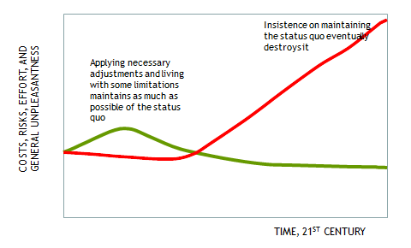

A cynic would say this easily explains the Paradox. If you cannot see into the future you are likely to choose the easier path. And this is even more the case for collective decisions. A cartoon version of the graph illustrates this:

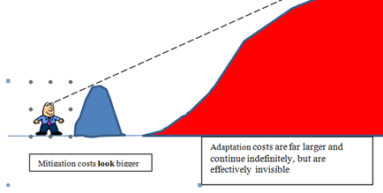

The Paradox only emerges when we acknowledge that for the purposes of this problem, we can see into the future. Sober analysis pretty well anywhere tells us what we need to do to stay within the 2 degree boundary, and in the larger perspective it’s not really so bad at all.

How ‘bad’ might it be? Nicholas Stern in his 2006 review thought mitigation might cost something like 1% of the world GDP for about 30 years, and he later revised it to 2%. I think, frankly, it would be more like 5% for the next 50 years, or even more, similar to expenditure on ‘defence’ in an all-out war situation (in Germany in 1944 it was said to be 40%).

You can see that this would be politically difficult, but not unprecedented. And it is nothing relative to what comes later. You can do the sums yourself, based on published estimates and the ‘discount rates’ applied by various economists (Stern’s was 1%
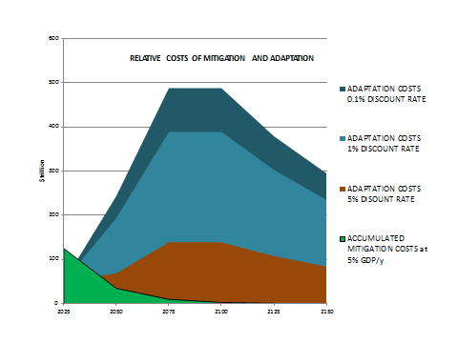

Speaking as an ordinary human being I would say it was not only unfair but faintly daft to balk at paying the relatively modest mitigation costs in order to forestall overwhelmingly likely larger costs in the future.

The phrase ‘large costs’ is a euphemism for, among other things
Increasing amplitude of climatic extremes
Increasing physical pressure on tropical states and communities
Sequential and domino state-collapse, initially in the tropics
Inter-state wars
Rise of local warlords and local gang culture
Mass unplanned population movements
Tens of millions of environmental and political refugees
Collapse of global inter-state system and UN oversight
Desperate and grossly inefficient exploitation of natural biomass
Widespread and irreversible loss of habitat and mass extinctions

That’s the tropics and developing world. In the higher latitudes there is better infrastructure and higher technical resilience, and (especially above 50° latitude) there will be temporarily improved capacity in agriculture and some other sectors.

In the rich ‘northern’ world, states can probably continue to function indefinitely. Of course the rich nations will have physical climate-related problems too, but can probably cope. Their problems will be of a political nature. Once the main collapses have started in the South they will be hard to stop. The rich North will be under the strongest pressure to switch from ‘let’s help everyone’ Guardian-style morality to ‘too late now, sauve qui peut’ Mail-style morality. ‘People like us’ will be urging food aid, but this will not really touch the problem. Others will be baying for gunboats in the channel to sink the armadas of refugees. We will be forced to make the most horrible choices about who will live and who will die. Along the way a lot of ‘nature’ will get terminally trashed (but—emblematic of the times—few will care, until the lack of key ‘ecosystem services’ start to generate their own domino effects).

What I am charting here is the permanent reversal of the ethical progress we have made in the last 100 years and a complete redefinition of what we hitherto thought the highest aspirations of humanity. There will be defensive blocs of states, and probably some that go it alone. Possibly not wars, but threats and nuclear blackmail. Democracy in some sense might survive, but it will necessarily be of a mean-minded, xenophobic, apartheid-based kind. Terrorism will be endemic. Elites will protect themselves in heavily-armed enclaves. Completely horrible, and no end in sight.

OK, to wrap up my argument, the choice before humanity is
- Modest costs up front to maintain the benign physical and moral climate, perhaps like an insurance premium,
OR
- Completely god-awful costs later down the line, mostly visited on our descendants and fellow passengers of Spaceship Earth. Plus collapse of our ‘moral programme’.

Seems a no-brainer, but can we get more than a handful to pay due attention?
Probably not.

Giddens’ Paradox means that we are probably in a transition period right now when the last options for maintaining the present benign climate regime are losing their relevance. I have the strongest feeling that whichever way it goes, the historians of the future will regard 2010-2020 as the most pivotal decade in all of history, when the die was cast.

I wonder, will it still be called Giddens’ Paradox?

A vulgar part of my mind cannot help thinking of Stanley Holloway’s Albert Ramsbottom and his “stick with its ’orses ’ead ’andle”, but perhaps this is too facetious a comparison.

