COMPARISON OF ENVIRONMENTAL IMPACTS OF OPEN COAL-FIRED HEATING WITH CENTRAL HEATING USING NATURAL GAS
Peter Harper
May 2018

I am a teacher at the Graduate School of the Environment. From time to time I am challenged by students to justify various statements I make in lectures, and this is just how it should be. But sometimes the challenges are about things so ‘obvious’ that I have not even bothered to give any evidence or argument at all. In these cases, it forces me to go back a long way and ask very fundamental questions. Could black really be white after all?

In April I claimed that the transition from open coal fires to natural gas central heating in the UK was one of the biggest revolutions in environmental quality. On the face of it, there is hardly any argument to be had. Coal has a carbon-emissions intensity of about 350 g/kWh, natural gas about 200 g/kWh; coal fires are typically about 15% efficient, gas central heating about 80%. Multiply these figures together and you get a ratio of 23.3: 2.5 or about 9.3 to 1. Compare this with other technical improvements such as hybrid vehicles. Hybrids are up to 50% ‘better’ than conventional vehicles and this is considered a significant improvement. Surely an improvement of 830% would count as pretty fundamental? And that’s just CO2 emissions. Add in the spoil heaps, occupational risks, transport emissions, storage, smog, coal-ash disposal and the sheer filth of coal at all stages, and compare this to the silent and virtually invisible gas: surely there is no comparison? And yet a bold student called me out!

Maybe she had a point. An energy-conscious architect friend of mine (incidentally a former Director of CAT) once remarked that ‘the rot set in with central heating’. Aha. You can see what he meant: coal-fires were such a pain they dominated life and forced everyone to endure cold in other parts of the house and wear very warm clothes. In many houses there were open fires in every room, but they were almost never lit. It was far too much trouble for little gain. But once gas central heating appeared, you could magically have warmth everywhere, all the time. Of course, in principle you could still operate central heating like a coal fire. You could have the radiator on in one room and keep the others unheated, just as before. The difference in emissions would be simply that between the relative efficiencies and the Emission factors, i.e., 0.15/0.34: 0.85/0.2, again a difference of over 800%, if we strictly compare like with like. But this is not how gas CH is normally used, and space heating energy consumption per person was higher in 2010 than it was in 1970.

In the early 70s UK space heating demand was 250 TWh/yr, mostly coal, for 18.8 million dwellings, so about 13,000 kWh per household. In the late 00’s space heating demand was higher, 350 TWh/y, but for a larger number of dwellings, 27.1 million. This also generates around 13,000 kWh per household, although household size is now smaller, so heating energy per person was greater in 2010, 5,600 kWh, while in 1970 it was 4,400: 27% less.

This illustrates a very widespread phenomenon: that improvements in technological efficiency are not usually used to reduce environmental impacts, but to increase comfort and convenience and reduce costs. In this case it has actually increased raw consumption, even though emissions and most other impacts have gone down. Factoring this in, the space-heating emissions in 2010 are ‘only’ 25% less than in 1970, not such a game-set-and-match.

Regarding non-CO2 environmental impacts, most cannot easily be quantified, but there would probably be general agreement on the judgements in the following table. In each row, the environmental impact deemed greater is highlighted.

 | Coal open fire | Gas central heating
Extraction | Coal mines, high occupational hazards, spoil heaps, visual intrusion, wider social risks, soil and water pollution | Steel/concrete rigs, largely out-of-sight out-of-mind; fracking greater impact than offshore rigs but less than mining
Transport | Open rail wagons, truck, sacks: transport energy | Underground pipelines: relatively small pumping energy
Delivery and storage | 1cwt sacks, very filthy! Bunkers | Invisible
Conversion devices | Grate, flue, chimney | Boiler, pipes, radiators: higher embodied energy
Supplementary heating | Electricity, kerosene. Would reduce efficiency because open fires extract warm air | None
Hot water | Sometimes back-boiler, very inefficient in summer; often electric immersion-heater | Provided by gas boiler; gas has lower emissions than electricity
Maintenance | Annual chimney-sweeping, removal of soot and char in chimney | Annual servicing, replacement every 15 years
Operational impacts, convenience, amenity | Fire preparation, not a clean process; daily cleaning, ash disposal. Hard to control | Invisible, easily controlled either manually or automatically
Routine waste products | High CO2 production; smoke with carcinogenic chemicals, particulates, sulphur, acid rain, smog-forming items; high-sulphur toxic ash | Lower CO2 production, no solid waste
Toxics | Risk of CO from incomplete combustion | Some risk, but lower
Fire risk | Low but acknowledged risk; chimney fires | Negligible risk
Explosion risk | None | Low but possible
Overall efficiency | 14% | 70%

With regard to airborne emissions referred to in ‘Routine Waste Products’, some quantification is provided by DEFRA in the following graph covering particulate and NO_{x} emissions from a variety of heating sources. The contrast between coal and gas is more than striking – but note that some other greenie favourites also compare poorly with gas CH in this respect.

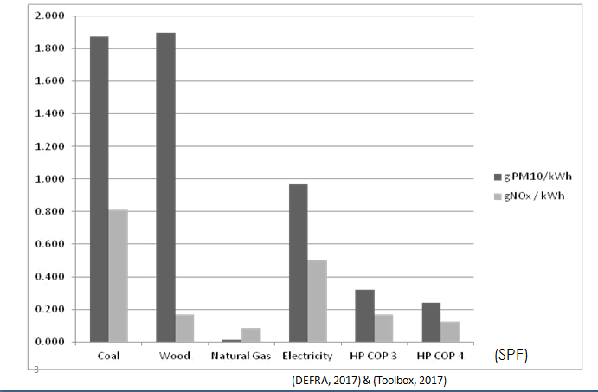

The raw data concerning GHG emissions are in the following table, and derived statistics in the subsequent table, making the simplifying assumption that most households used coal in 1970 and most used gas in 2010. The interpretation is crucially dependent on the ‘functional unit’ (per unit of what?) used as the denominator of an intensity measurement.

 | Open coal fire, 1970 | Natural gas Central Heating 2010
MWh/y | 250 | 350
# dwellings | 18.8 | 27.1
Household size | 3 | 2.3
Carbon intensity | 0.34 | 0.2
Efficiency 1970 | 0.14 | 0.7
Efficiency 2010 | 0.1 | 0.85

 | Coal | Improvement ratio | Gas
MWh/dwelling | 13.30 | 1.03 | 12.92
MWh/person | 4.43 | 0.78 | 5.62
Emissions per dwelling, tCO2/y | 4.52 | 1.75 | 2.58
Emissions per person, tCO2/y | 1.55 | 1.38 | 1.12
Emissions per heating kWh delivered, kgCO2e/kWh 1970 | 2.42 | 8.3 | 0.29
Emissions/unit heating 2010 | 3.4 | 14.5 | 0.24
The normal ‘functional unit’ used by economists and perhaps politicians would be the final one, emissions per useful unit of energy. Measured in this way the gas system is 8 to 14 times ‘better’ than the coal system. This supports the claim that the switch from coal to gas in the UK was one of the most significant environmental advances. However, it could be argued that the great increase in efficiency was ‘used’ merely to improve comfort standards, not to reduce emissions, which were only about 30% lower per person in 2010 relative to 1970. This is still significant, but not as dramatic as the 830% based on the ‘functional unit’.
And it could easily be asked, did all this extra heating create greater comfort, or improve the quality of life? Surely a bit, and we wouldn’t want to go back. But not 850%!

So the student was right to raise an eyebrow. It depends what you are measuring and how.

Hermann Muthesius, The English House (Janet Seligman, Trans.), in: Dennis Sharpe (Ed.), Crosby Lockwood Staples, London, 1979, p. 17
J.Utley and L. Shorrock, Domestic Energy Fact File. BRE (2008) https://www.bre.co.uk/filelibrary/pdf/rpts/Fact_File_2008.pdf
This is a coarse guesstimate. Open fires usually draw air from the room they are in. By 2010 there were many supplementary sources of heating in houses with coal fires, and an open fire would tend to abstract the warmed air and send it up the chimney. It is widely thought that they could actually achieve negative efficiencies. In view of this effect, I have modestly reduced the 14% reported in Ref 1.
A useful discussion of the social factors behind the switch from coal to gas is found in L. Kuijer and Matt Watson ‘That’s when we started using the living room’: Lessons from a local history of domestic heating in the United Kingdom. Energy Research and Social Science, 28, 77 (2017). This argues that although technological change facilitated increased energy consumption, it it did not drive it.

