CLASS AND DIETS
A controversial matter

Comments by Peter Harper

Students might consider this topic as a coursework essay or even as a dissertation.

There is a very large literature, both academic and popular, about the association between income and food choices/food behaviours, and nearly everybody is aware of it through personal experience. The problem for this course is that the choices we tend to favour roughly match the choices of higher-income, middle-class people, and especially those of the so-called ‘metropolitan elite’. Students on the course are likely to be from this demographic segment themselves – although I stand to be corrected here. We have to be careful we are not merely reinforcing our pre-existing preferences.
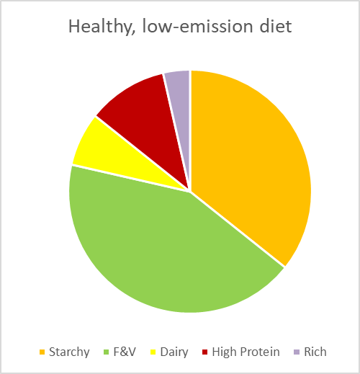
We have been trying to model diets that are both healthy and low-carbon. In terms of the pie charts of the relative quantities of five principal food classes, our choices tend to come out like the chart shown in Figure 1:

In contrast, the average UK diet comes out a bit like Figure 2:
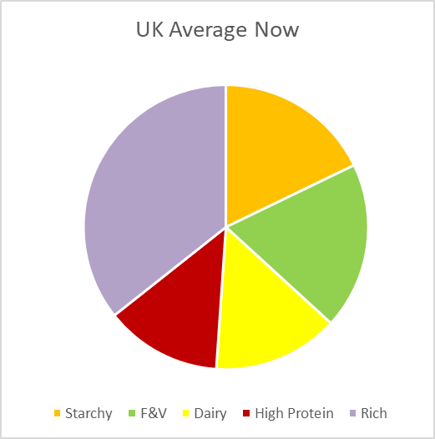
Figure 2

Figure 1

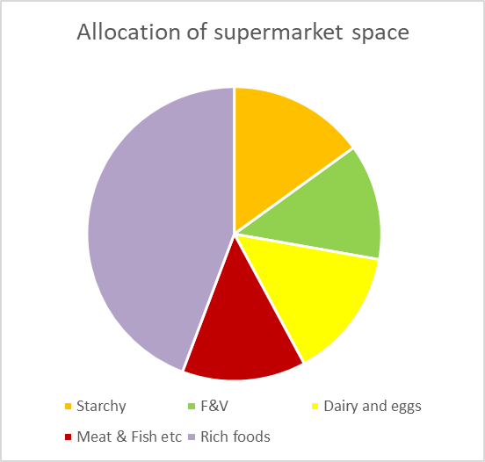
In further contrast, when we both imagined and measured the allocation of supermarket shelf space, we got a result like Figure 3:

Figure 3
If higher-income people are preferentially eating Figure 1-type diets, and Figure 2 is the average, it suggests that lower-income people are eating diets more like Figure 3, which broadly speaking are neither healthy nor sustainable. But are such diet types in some sense rational, or at least explicable, culturally or economically?

We have been using a Health Scoring system that emphasises foods with health-promoting ‘nutrients’ over foods with a high energy-density. It asks: Given a standard UK diet, which foods should you eat more of, and which less of, to improve dietary health? But the system does not tell you what would be best if you’re starving in the desert, when a cream bun would be worth a hundred times more than a lettuce. In that case, you want energy-dense foods. But this might go some way to explaining traditional preferences of poor people for starchy, sugary and oily foods which have high energy densities and ‘fill you up’. Chips, not kale.

The idea is given some support if we re-analyse our food categories cost data in terms of dry matter content rather than weight as sold in the supermarket, which inevitably includes water in varying amounts, often quite a lot. And yes, on these calculations energy-dense foods are usually cheaper. Figure 4 below shows some of our rough and ready data reanalysed from this perspective (cheap at the top). Of course, this is based on a quick pedagogical exercise rather than sober analysis of the raw data, but is probably not far from the truth.

Figure 4

I can vouch for this ranking from childhood experience in ‘the age of austerity’ after the War. I had lunch at my grandmother’s and it was always egg and chips. When I got home it was bread and butter and jam, and tea with milk and sugar. All these items are at the cheap end, then as now. We were not particularly poor, but it seemed that everyone was in the same boat.

There are other ‘economic’ explanations too. One I like is that children intrinsically hate vegetables – at first. Why? The most usual explanation is that many plants produce bitter and rather disagreeable compounds to deter herbivores from eating them. Our evolutionary background prompted young children to avoid anything unfamiliar that tasted bitter or strange, and they needed to be ‘trained’ to accept plant foods. This remains the ‘default setting’. But through long exposure we often get to enjoy the peculiar flavours of plants, even though these derive largely from defensive chemicals.

It takes time to overcome children’s natural resistance. Richer parents can afford to keep offering foods that are initially wasted. Eventually persistence pays off, and richer kids come to regard these as attractive foods. In contrast, poorer households cannot afford to waste food like this, so they just give children what they ‘naturally’ like – mostly energy-dense foods, and high levels of sugar, salt and oil. These poorer kids never get to acquire a taste for vegetables.

But there is an equally large literature suggesting that diets represent important markers of culture and identity, and that even wealthy people from poorer backgrounds might maintain their original diets. The French social scientist Pierre Bourdieu used the notion of ‘habitus’ to describe the complex set of habitual behaviours, tastes, customs and opinions that map closely onto ethnicity and social class. Habitus is not easy to change, and diet is often an integral part.

Occasionally of course, people do ‘escape’ into the middle class, or their parents morph a bit, and diets might change, if slowly. This was notably true in the 50s and 60s when a huge expansion of managerial and white-collar jobs ‘embourgeoised’ a section of the working class. As I grew up I noticed a shift as my parents used dietary change as a marker of their rising social aspirations. There are plenty of anecdotal accounts about the experience of ‘becoming middle class’.

Still, it seems the typical energy-dense diets are resistant to change. In addition to the evolutionary avoidance just mentioned, it seems likely that the opposite situation also exists: that there are innate ‘hungers’ deriving from a time in the evolutionary past when it made sense to avidly seek sweet-tasting things (to provide calories); salty things (to provide minerals); and fats and the ‘umami’ taste associated with meat (to provide oils and protein). These were rare in nature and difficult to obtain, but the urge to satisfy these hungers delivered an adequate and balanced diet. It was impossible to overdose.

To use computer terminology, we might say these are the biological ‘factory settings’ for dietary preferences, which will be followed unless deliberately re-set.

Fast forward to post-modern societies and sweet, salty, oily and umami tastes are available in overwhelming abundance in energy-dense foods. They are extremely palatable, as Pamela Mason remarked in her lecture. They are hard to avoid, somewhat addictive, generally very cheap, and heavily pressed on children and adults through a wide range of marketing strategies. The ‘factory settings’ for preferences make overconsumption much more likely, and this can displace other types of foods.

These addictive foods are nearly all energy-dense, and this coincides with an economic incentive for poorer people to choose energy-dense foods. The adoption of such foods then easily becomes a marker of group identity, and an important part of a ‘habitus’ with considerable coherence and resistance to change. This might be one of the reasons for the emergence – and persistence – of the classic energy-dense ‘working class diet’.

‘Food reform’ since the 19th century has tended to emphasise nutritional components other than energy and protein (which can be assumed abundantly available in an industrial society). These other components include vitamins, minerals, fibre and a wide range of supposedly beneficial principles that might protect against illnesses such as cancer in the ‘nutrient-rich’ diets as opposed to ‘energy-rich’ diets. Typical energy-rich diets not only overdose with foods that are beneficial in moderation, but often systematically avoid the extra nutritional factors. There are clear health implications for these types of diet.

This is particularly true of the so-called ‘ultra-processed foods’, of which the UK is now the highest consumer in Europe. The pie-chart in Figure 3 reflects this dominant component of the UK diet, which is disproportionately consumed by lower-income groups. This component is strongly associated with obesity and Type 2 diabetes.

It is striking that the discussion so far has little to do with meat. Although there is some association between social class and meat consumption, meat and fish/dairy/eggs are consumed by people of all social classes, and provide around 60% of the protein, plus many other minerals and vitamins. They are an important part of the general UK dietary habitus. Although eating too much meat, and especially fatty red meat and processed meats, can increase the risk of some health problems, meat is probably a net health benefit for people eating low-nutrient diets. It is also, of course, highly palatable.

On cost, measured both in ‘as bought’ terms and in dry matter, meat and fish look relatively expensive, so we might assume high consumption cannot be attributed to raw economics. The averaged statistics however, combine both high and low values, and it is probable that poorer people preferentially consume cheap meats. In our statistics, non-carcass meat came in at about 1.23 p/g but of course there are much cheaper meats on sale. Tesco for example does a ‘beef’ burger at around 0.9 p/g and a cheap bacon at around 0.3 p/g, cheaper than eggs and milk. In the 50s it was common to eat tinned meat, and you can still get spam and corned beef at around at 0.6 p/g, but these again are highly-processed foods.

For economic, taste and health reason therefore, it might be harder for poor people to reduce their meat consumption. For this Course, the problem is that we are concerned both with environmental impacts (of many kinds) and health effects of what we all eat, but our ideal diets seem to collide head-on with culturally-embedded preferences in lower-income groups. More crudely put, are we at odds with a significant aspect of working class culture?

I have presented the case as I see it, but there is considerable scope for disagreement. However controversial, this is an issue that cannot be ducked and deserves further discussion.

“The peculiar evil is this. A millionaire may enjoy breakfasting off orange juice and Ryvita biscuits; an unemployed man doesn’t…. When you are unemployed, which is to say you are underfed, bored, harassed and miserable, you don’t want to eat dull, wholesome food. You want something a little bit tasty”.

George Orwell, The Road to Wigan Pier, 1937.

APPENDIX

Table of foods deemed to be high-energy and nutrient-poor, largely matching the ‘Rich Foods’ category in our pie charts. Taken from Andrew Drewnowski, Towards a Nutrient Density Score. Am J Clin Nutr 2005; 82:721–32.

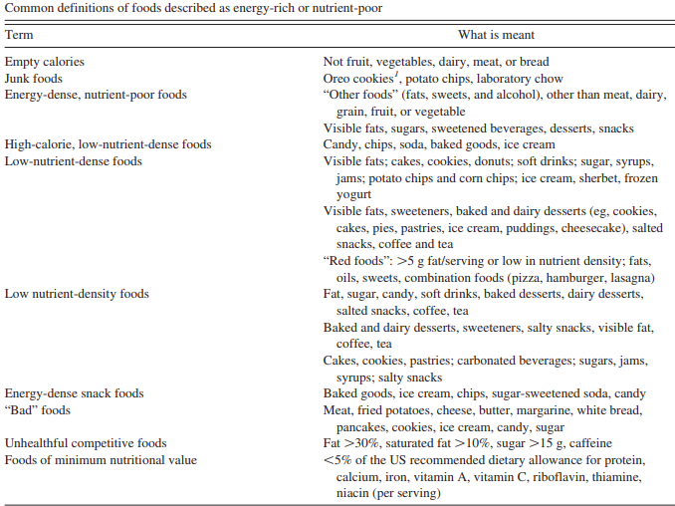

Consumption of such foods is claimed to be associated with poor mental as well as physical health, as in the emerging discipline of ‘nutritional psychiatry’. See for example
W. Marx et al., Nutritional psychiatry: the present state of the evidence. Proc Nutr Soc. 2017 Nov 76(4):427-436.

For a popular example, see https://www.euractiv.com/section/economy-jobs/interview/professor-there-is-a-link-between-poverty-and-unhealthy-diets/
An excellent, if dated, review of various food-health rating systems can be found in Adam Drewnowski: What’s Next for Nutrition Labeling and Health Claims? An Update on Nutrient Profiling in the European Union and the United States. Nutrition Today, 42 (5) (2007). Drewnowski’s table of rich foods can be found in an appendix at the end of this essay. See also Peter Scarborough, Anna Boxer, Mike Rayner and Lynn Stockley: Testing nutrient profile models using data from a survey of nutrition professionals. Public Health Nutrition, 10 (4) 337 (2007). These latter authors represent the academic elite of British nutritional profiling, and come down in favour of the system used in ZCB and our spreadsheets.
. See for example Annie E. Wertz and Karen Wynn: Thyme to touch: Infants possess strategies that protect them from dangers posed by plants, Cognition 130, 44 (2014), or more popularly http://www.huffingtonpost.com.au/2016/12/08/hated-veggies-as-a-kid-these-are-the-scientific-reasons-why_a_21622833/.
Caitlin Daniel: Economic constraints on taste formation and the true cost of healthy eating. Social Science and Medicine, 148, 34 (2016).
The Wikipedia entry on Habitus is a good introduction.
See e.g:http://www.telegraph.co.uk/foodanddrink/10277627/Jamie-Oliver-is-half-right-about-why-the-poor-eat-junk.html . More generally, Lynsey Hanley Respectable: How I became middle-class. Allen Lane (2016). A particularly trenchant account is Hillbilly Elegy by J.D.Vance, Harper 2016.
Literal sweet tastes are extremely rare in nature, but starchy foods become sweet if exposed to mouth enzymes after thorough mastication.
Paul Breslin: An Evolutionary Perspective on Food Review and Human Taste. Current Biology 23 (9) 2013. See also Gary Taubes: The Case Against Sugar, Portobello Books (2016).
Maguire, E.R. and Pablo Monsivais. Socio-economic dietary inequalities in UK adults: an updated picture of key food groups and nutrients from national surveillance data. Br J Nutr. 2015 Jan 14; 113(1): 181–189.
A special edition of the journal Public Health Nutrition is devoted to such foods: https://uploads.guim.co.uk/2018/01/12/PHN_links_for_all_papers_in_the_special_issue_on_UPF.pdf. See a popular report here: https://www.theguardian.com/science/2018/feb/02/ultra-processed-products-now-half-of-all-uk-family-food-purchases?CMP=Share_iOSApp_Other
The classic source is John Yudkin’s Pure, White and Deadly, Viking 1986, but the argument has been brought up to date by Robert Lustig, Fat Chance: Beating the Odds against Sugar, Processed Food, Obesity, and Disease. New York: Hudson Street Press (2013).

