BUILDING MATERIALS DERIVED FROM MISCANTHUS
(AND OTHER HIGH-YIELDING CELLULOSIC CROPS)
A suggestion from Peter Harper

Miscanthus is normally grown as an energy crop, but other potential uses deserve exploration. In a ‘decarbonisation’ context, use as a sequestration material could be more important, and economically advantageous under conditions of high carbon prices, since sequestration is carbon-negative, while energy is at best carbon-neutral. Several recent analyses of the climate situation suggest that internationally-agreed targets cannot be met without net-negative processes (Anderson and Bows, 2008), and of the wide variety of counter-forcing processes, growing and sequestering plant material has the best pedigree (Lal, 2008)

Biomass crops like miscanthus can in principle be harvested and stored (or sequestered) by deliberate burial on land (Zeng, 2008) or in the deep ocean (Strand and Benford, 2009). A more attractive and economically favourable fate might be to incorporate miscanthus biomass into goods (as biopolymers after appropriate chemical transformations) or into buildings (for example as biocomposites or compressed boards, Biocomposites Centre, 2011).

Incorporation into buildings is particularly attractive because it might serve many functions in addition to sequestration. Insulation is an obvious example, and can be compared with the now widely-used hemp-lime composite, commonly sprayed into a shuttered void (Bevan and Woolley, 2008). This assumes a pre-existing structure to which loose non-structural materials can be added in various ways. If the principal structure is wood, this can already provider a ‘carbon credit’ and calculations have been carried out to assess the value of this aspect of wood in buildings (Forestry Commission Scotland, 2009). Further non-structural biomass materials would increase this value.

Materials like hemp and miscanthus suggest yet another possibility: their use as structural materials in much larger quantities. There are of course innumerable examples of pure-tension structures that do not incorporate rigid materials like timber, steel or pre-stressed concrete (Fitchen, 1961; Fathy 1976). The disadvantage of avoiding rigid elements is that usually a great deal more material is required. Since materials are costly, architects have developed a strong instinct for minimising the mass of materials employed. But if there are positive benefits and cash flows associated with the use of some materials, this design principle might well be weakened or even thrown into reverse.

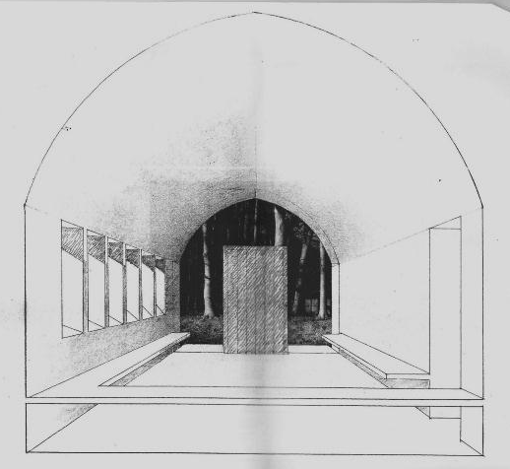
The architect David Lea has designed a thick-walled vaulted structure using hemp-lime as a structural material, and it is intended to realise the idea at full scale at St Fagan’s National History Museum, Cardiff. This shows a proof of concept. Hemp is an excellent material but is derived from an annual plant grown in arable rotations, with necessarily limited areas. Miscanthus, a perennial grass, could potentially replace perennial forage grasses in much more abundant permanent pasture, giving much higher potential output. Could it behave similarly to hemp? The present proposal is to carry out trials of miscanthus biomass in various forms to create permanent structures, while quantitatively assessing sequestration value.

The long-term goal is fairly clear – to provide a tangible sink for carbon within the building stock. CAT’s ZeroCarbonBritain study estimated that retrofits and other routine uses could incorporate 16Gg a year in the UK (CAT 2010). Deliberate redesign of new buyildings fopr sequestration could possibly double this figure to around 30Gg. This is small relative to present UK emissions, but it has been demonstrated that in various ways UK emissions could be reduced to under 70Gg, against which 30Gg of sequestration is a worthwhile proportion.

In the short term however, incorporation of sequestering materials could help achieve government targets for building performance. In spite of the fanfare surrounding ‘zero-carbon buildings’, these are proving very difficult to deliver. If however a building is extremely well-insulated with ‘cheap’ materials, generates a certain amount of energy, and is made from carbon-negative materials, the building could balance its life-cycle emissions to less than zero. The range of logical possibilities is laid out in the figure below.
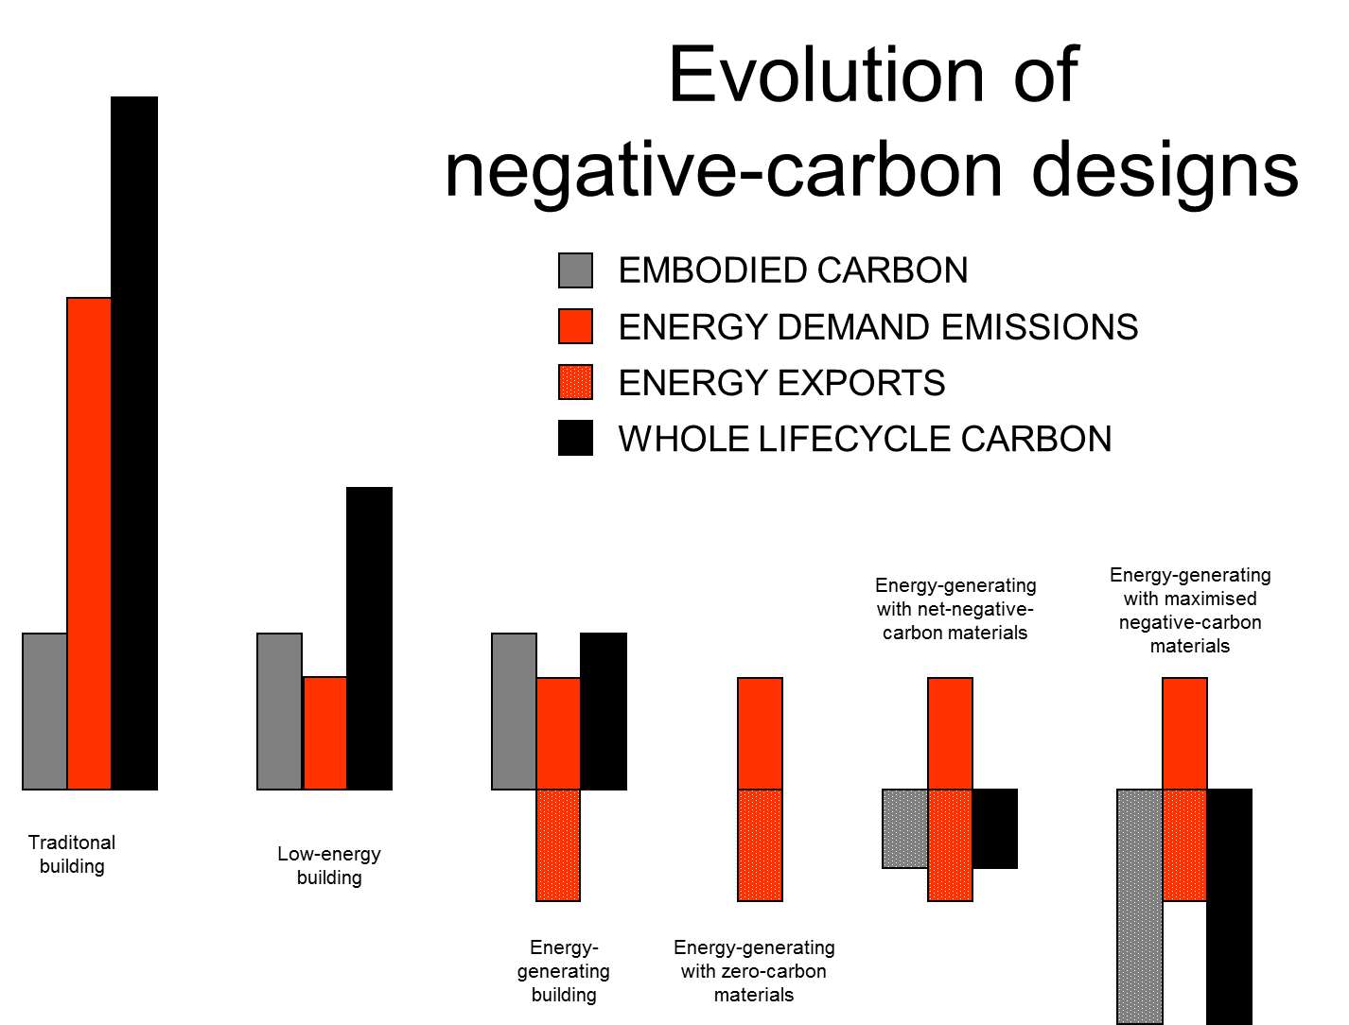

In future it is possible that planning consents for structures could be based on expected life-cycle emissions and negative embodied carbon could be a key design feature.

REFERENCES
Anderson, K., and Alice Bows, 2008. Reframing the climate change challenge in
light of post-2000 emission trends. Phil. Trans. R. Soc. A. doi:10.1098/rsta.2008.0138

Bevan, R. and T. Woolley (2008), Hemp lime construction. A guide to building with hemp lime composites. NNFCC 07-001

Biocomposites Centre, University of Bangor. www.bc.bangor.ac.uk.

Centre for Alternative Technology, 2010. Zero-Carbon Britain 2030. CAT Publications.

Fathy, Hassan, 1976. Architecture for the Poor. University of Chicago Press

Fitchen, J. 1961. The Construction of Gothic Cathedrals: A Study of Medieval Vault Erection. Oxford, Oxford University Press.

Forestry Commission Scotland, 2009. Greenhouse Gas Emissions Comparison ­ Carbon benefits of Timber in Construction

Lal, Rattan, 2008. Carbon Sequestration. Phil. Trans. R. Soc. B 27 February 2008 vol. 363 no. 1492 815-830. doi: 10.1098/rstb.2007.2185

Strand S.E., and Benford G.,2009. Ocean sequestration of crop residue carbon: recycling fossil fuel carbon back to deep sediments, Environ. Sci .Technol. 43 (4) :1000-7.

Zeng, Ning, 2008. Carbon sequestration via wood burial Carbon Balance and Management 3:1 doi:10.1186/1750-0680-3-1

